JK-6生物组织摊烤片机
JK-6 Tissue spread roast machine

使
用
说
明
书
Instructions

武汉俊杰电子有限公司
电话：027-87401756 87411993 传真：027-87411995
网址：www.whjjbl.com 中文网址：病理器材
E-mail：junjiedianzi@126.com 邮编：430074
地址：武汉市东湖开发区武大科技园国家地球空间
信息产业基地二期北楼二单元1203室

前言Foreword

JK－6生物组织摊烤片机说明书是在执行《工业产品使用说明书-总则》国家标准，根据《医疗器械说明书包装的管理规定》制定。对产品的性能、结构、使用方法以及使用年限、产品的标签、标识的图形、符号等内容的解释。
生物组织摊烤片机的使用期限6年
JK-6 biological tissue spread roast machine instructions are executed "Industrial Product Manual - General" national standards, according to "medical device specification packaging regulations" to develop. Interpretation of product performance, the structure, method of use and age, product label, logo graphics, symbols and other content.
Tissue spread roast machine uses period of six years

一、注意事项
1、保持环境干燥，通风。
2、只在摊片水箱内加水，烤片箱内严禁加水，以免引起漏电。
3、摊片水箱不要随意搬动，以免水流入机内，造成短路烧坏机
件或发生触电事故。
4、使用时，妥善接地。
A Notes
1, keep the environment dry and ventilated.
2, just add water tank in the spread sheet, grilled slices of water inside the forbidden, in order to avoid leakage.
3, spread sheet should not arbitrarily move the tank to avoid water flows inside the machine, causing a short circuit burned machine
Pieces or electric shock.
4, when used properly grounded.
二、主要技术性能
摊片温度设置：0℃～99℃
烤片温度设置：0℃～99℃
烘片温度设置：0℃～99℃
工作电压：220Ｖ±22V 50 Hz±1Hz
Second, the main technical performance
Stand-chip temperature settings: 0 ℃ ~ 99 ℃
Grilled chip temperature settings: 0 ℃ ~ 99 ℃
Baking sheet temperature settings: 0 ℃ ~ 99 ℃
Operating voltage: 220V ± 22V 50 Hz ± 1Hz

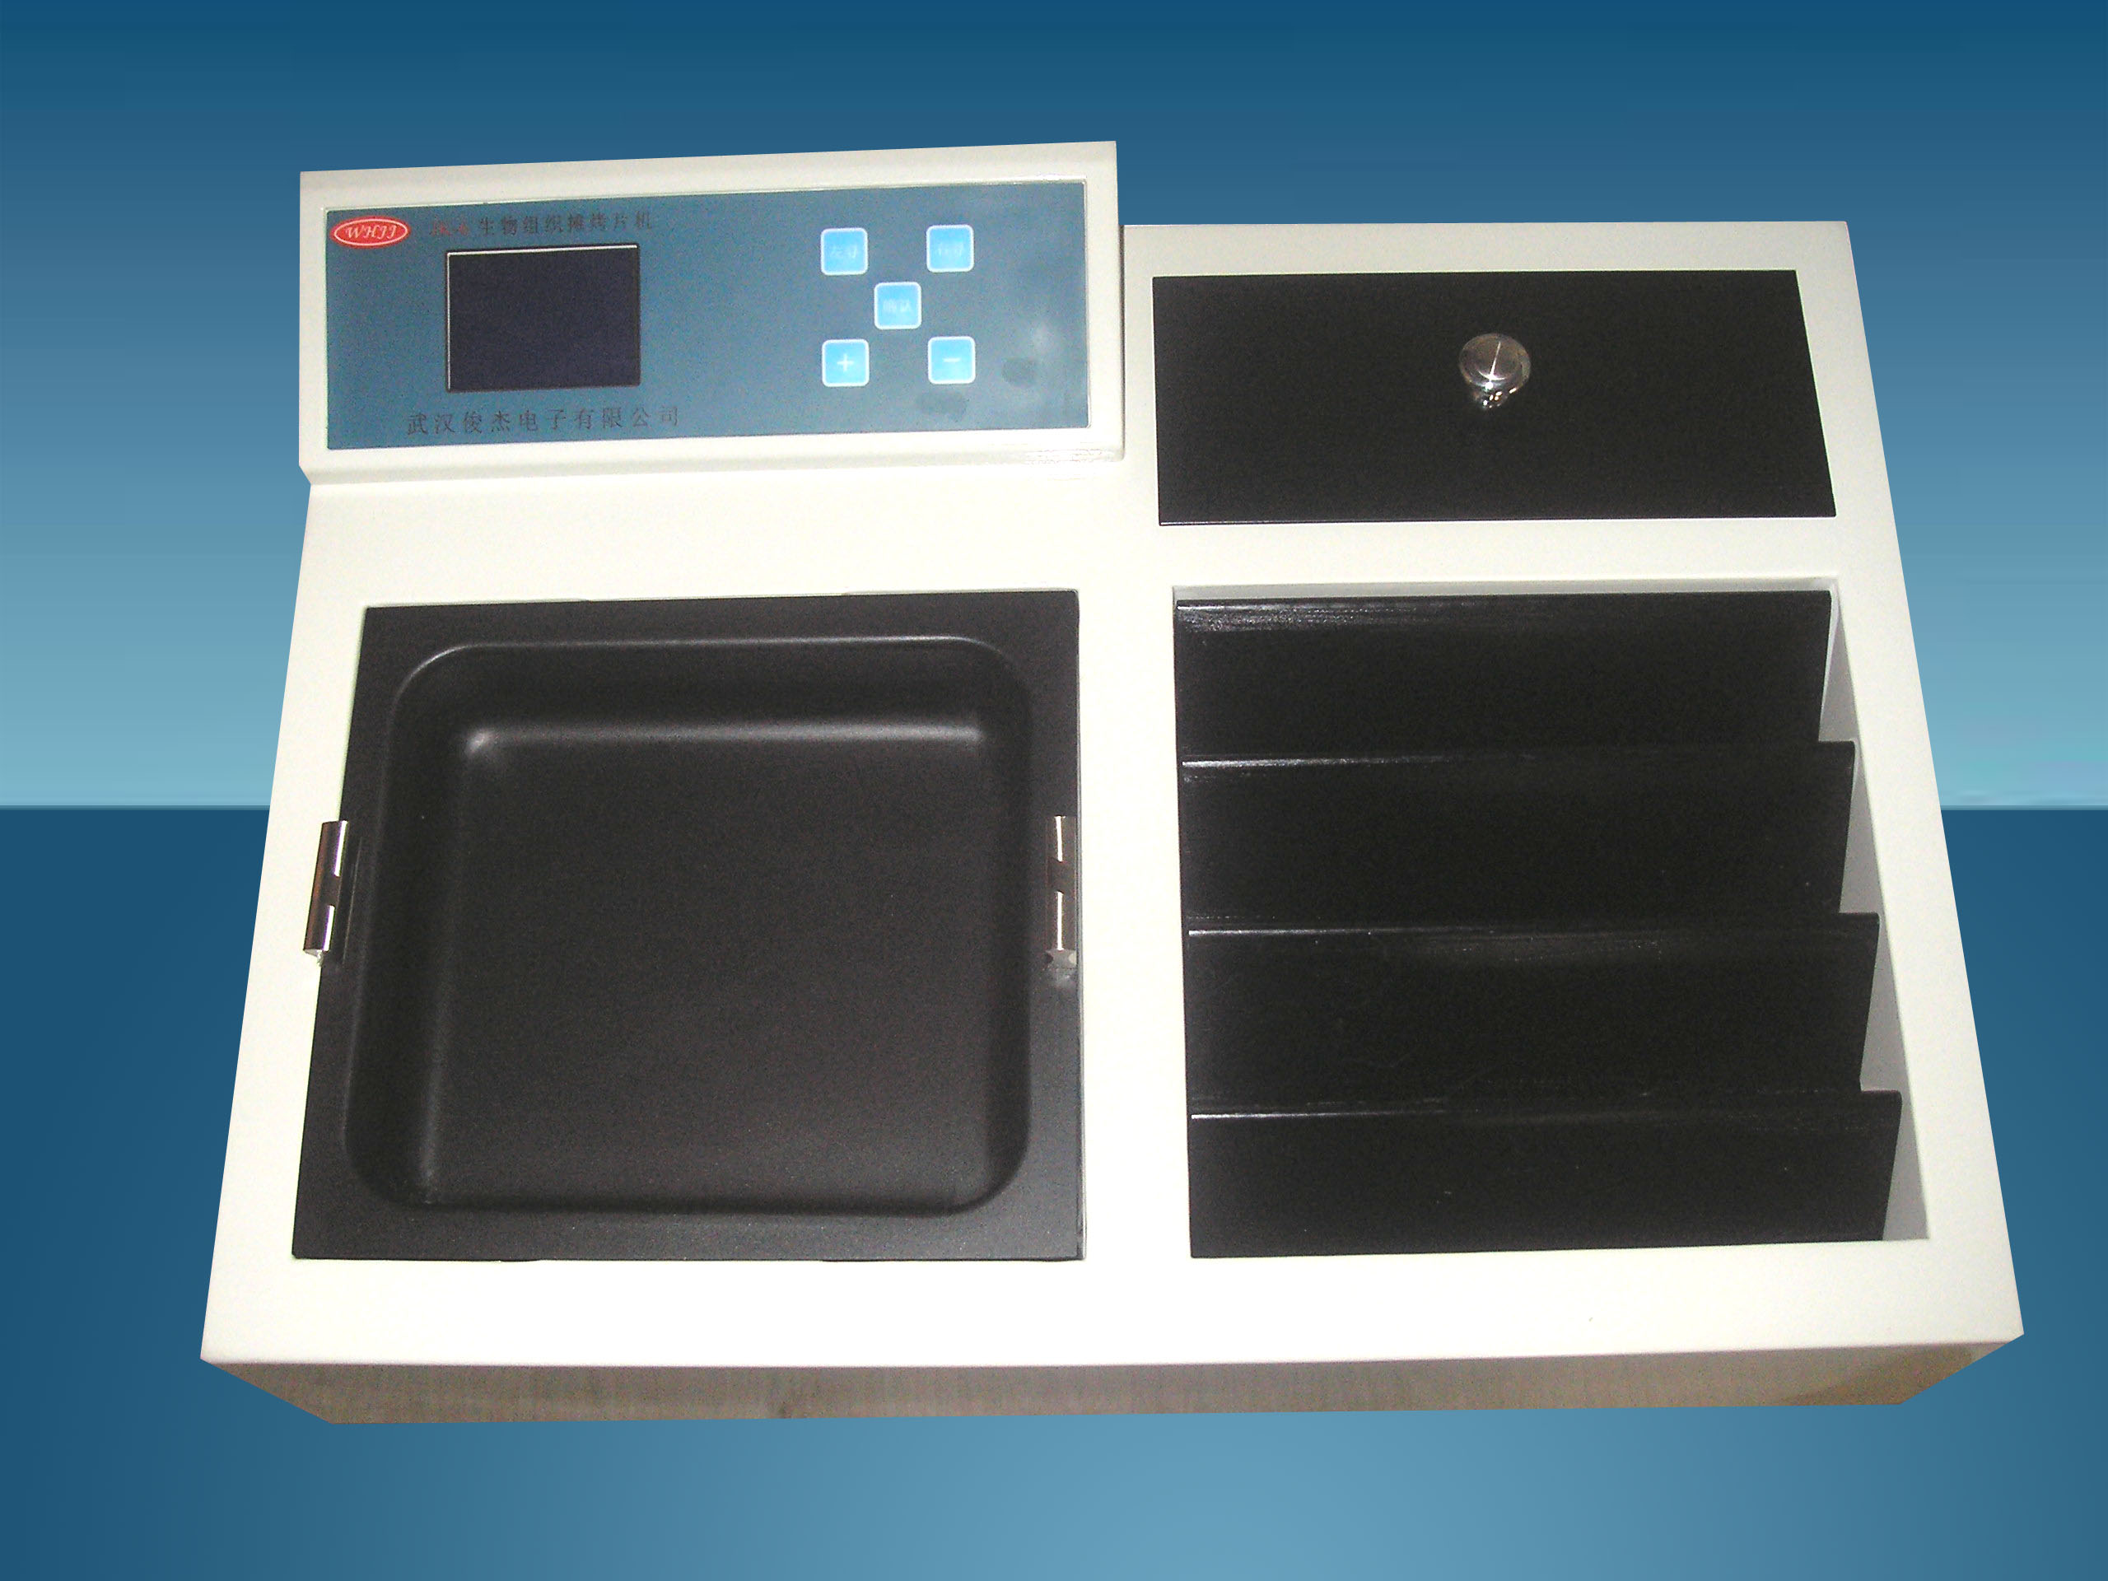

三、操作面板、键盘简介
1.显示屏 2.键面 3 .烘箱
4.烤片水槽 5 烤箱
Third, the operation panel, keyboard Introduction
1. Display 2. key surface 3. Oven
4. oven roasted piece sink 5

四、操作说明
- 注意：烤、烘箱内严禁倒水！！！
1.开机
1.将水加入摊片箱2/3的位置。
2.打开电源开关显示屏显示
Fourth, operating instructions
* Note: grilled, oven pour prohibited! ! !
1. Power
1. Water was added to spread the film box 2/3 position.
2. Turn the power switch display
→
武汉俊杰电子有限公司
功能选择
置温 运行

3.首次使用时应预置摊片、烤片温度，其预置方法如下：
操作“左寻”“右寻”键光标移至“置温”按“确认”进入设置温
度状态，操作“＋”“－”键，设置所需温度值。调至所需预置温度后，所预置的温度即自动进入电脑芯片。操作确“确认”键完成温度设置。
4.运行
操作“左寻”“右寻”键光标移至“运行”按“确认” 开始正常工作显示屏立即显示：
正在工作
摊片温度：XX度
烘片温度：XX度
烤片温度：XX度

3. The first time you use should be pre-spread slice, bake chip temperature, its preset as follows:
Operation "left to find" the "right to find the" key to move the cursor to "set temperature" press "OK" to enter the setting temperature
Degree status, operation "+" "-" button to set the desired temperature. After the preset to the required temperature, the temperature is automatically preset into the computer chip. Operating indeed "OK" button to complete the temperature setting.
4. Run
Operation "left to find" the "right to find the" key to move the cursor to the "Run" press "OK" to start to work immediately display screen:

5.摊烤片机达到设置温度后，进入自动加热恒温状态。
6.每次使用时，若不想改变预置温度，操作“确认”键即开始正常工作。
7.达到预置温度后，即可进行摊片工作。

烘、烤片：温度预置和使用方法于摊片相同。
5. spread grilled machine reaches the set temperature, into the automatic heating thermostat status.
6. Each time you use, if do not want to change the preset temperature, operating the "OK" button to start to work.
7. reaches the preset temperature, spread sheet work can be carried out.

Bake, broil film: temperature presets and use the same method to spread sheet.
2、关机
在 状态下，操作“确认”键显示屏显示：
正在工作
功能选择
置温 运行
此后关闭电源开关，摊片（烤片）机即停止工作。
Since then turn off the power switch, spread sheet (grilled slices) machine stop working.

五、保养
1、机器平放在水平位置，保持通风干燥。
2、机器外电源应有良好的地线与机器联通。
3、机器使用完毕后，应及时将机器表面的残物清理干净。
4、应定期对机器进行检修。
5、机器在正常的操作和保养下，使用期为6年。
Fifth, maintenance
1, the machine flat on a horizontal position, keep dry and ventilated.
2, outside the machine power and the machine should have a good ground connection.
3, the machine after use, the machine should be promptly surface residue to clean up.
4, the machine should be regularly inspected.
5, the machine under normal operation and maintenance, the use of a period of six years
六、故障检修
故障现象Symptom | 故障原因Cause | 排除方法Remedy
机器整机不运行The whole machine is not running | 保险丝熔断  Blown fuse | 更换保险丝Change the fuse
温度键输入失灵Temperature key input failure | 面膜开关坏Mask switch is broken | 更换面膜开关Change the mask switch
机器不加温Machine without heating | 加热管烧坏Heating pipe burn | 更换加热管Replace the heating pipe

装箱单

JK-6

机器 1台
Machine 1p
保险管（3A） 2只
Fuse
电源线 1根
Cable
说明书 1本
Instruction
产品合格证 1份
Product certification
验收报告单 1份
Acceptance report card
销售服务反馈单 1份
Sales and Service Feedback Form
装箱单 1份
Packing List
售后服务反馈单
Service Feedback Form
用户名称 | Name | 机器型号 | Type of machine
销售员 | Sales man | 合同号 | PO NO.
开箱人 | Unpacking people | 开箱日期 | Unpacking date
您对服务的满意程度: Your satisfaction with the service
很满意 □ Very satisfied 满意 □ Satisfaction 不满意 □ Dissatisfied 请打“√”
开机事项及客户意见
1、开箱后机器有无损坏，随机文件及备品、附件是否齐全？
Boot issues and customer feedback
1. After unpacking the machine for damage, random file and spare parts, accessories are complete

2、机器的使用方法及注意事项，业务(安装)人员是否讲清？
2, the use of the machine and precautions, business (installation) clarifying whether the staff?

3、您认为本机还有哪些地方存在不足，对机器有何建议？
3. What do you think of this machine where deficiencies, the machine have any suggestions?

客户签字：
年 月 日
请在填妥本单之后，由安装人员带回或传真邮寄的方式寄回即可成为本公司的产品注册用户。
Please complete this single later, brought back by the installer and return it by mail or fax to become registered users of the company's products.
武汉俊杰电子有限公司
设备安装验收报告单
Wuhan Junjie Electronics Co., Ltd.
Equipment installation and acceptance report card

设备名称 |  | Device Name |  |  | 设备型号 |  | Equipment Type
用户名称 |  | User |  |  | 用户地址 |  | User Address
使用科室 |  | Use department | 科室主任 | Department director |  | 电 话 |  | Tel
 |  | Use department | 使用人 | User |  | 电 话 |  | Tel
到货时间 |  | Arrival time |  |  | 合同号 |  | PO NO.
安装情况Installation | 仪器安装调试运行正常,技术指标符合说明书要求,可以交付使用Equipment installation is operating normally, technical indicators in line with the requirements of the specification can be delivered  安装人签字: Signature  年 月 日
验收情况Acceptance of the situation | 仪器包装良好,配件齐全,使用正常, 技术指标符合说明书要求,本单位确认验收合格. Instrument package good, complete accessories, using normal, technical indicators in line with the requirements of the specification, the unit to confirm acceptance.  科室签字: Signature 医院盖章: Stamp  年 月 日
武汉俊杰电子有限公司
电话：027-87401756 87411993 传真：027-87411995
网址：www.whjjbl.com 中文网址：病理器材
E-mail：junjiedianzi@126.com 邮编：430074
地址：武汉市东湖开发区武大科技园国家地球空间信息产业基地二期北楼二单元1203室

